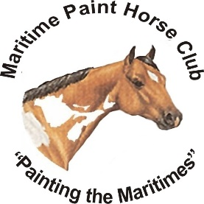**MARITIME PAINT HORSE CLUB**

2024 Membership Form

c/o Sarah Weeks

91 Pipertown Road, Summerville NB, E5S 1E6



\*\*\***CARRIED OVER IN 2024**\*\*\* If your new membership or renewal is received by **March 31, 2024** you will receive a $10 credit towards your show fees for the 2024 Southern NB Show in Sussex, NB (only one credit per membership – one credit per family).

**LIABILITY INSURANCE COVERAGE** (available automatically with your membership in any of the 3 Provincial organizations – NBEA, NSEF, IHC) will be **ASOLUTELY MANDATORY** when participating in ANY Maritime Paint Horse Club and/or American Paint Horse Association sanctioned events.

**WAIVER**

I hereby apply for membership with the Maritime Paint Horse Club (MPHC). I and/or my representatives or family agree to be bound by the rules and constitution of the MPHC and the American Paint Horse Association (APHA). I further agree to assume full responsibility for my safety and that of my children, horses, and property while at any MPHC approved event.

I hereby release the MPHC and/or its officers and directors from any and all claims or damages arising from any accident, injury, loss, or theft which is caused by or arises from the participation of the applicant or his/her family named herein, during any function at any facility or location where an MPHC sanctioned activity is held.

I authorize the MPHC to use my name or image in their publications (website, newsletter, etc.) as it pertains to MPHC activities.

I understand that MPHC does not carry personal liability insurance on behalf of the competitors and therefore I am responsible for obtaining such insurance. MPHC strongly recommends that competitors carry such insurance, as this insurance coverage will be **MANDATORY** for all participants in all MPHC sponsored events. MPHC will make every possible effort to ensure the safety of all involved persons, however, I understand that participating in any MPHC approved activity is entirely voluntary and wholly at my/our own risk. Should some condition arise that I consider to be unsafe, I will advise officials of said condition and if the condition is not rectified to my satisfaction, I will withdraw from further competition. I understand and accept there will be no refund of fees.

Signature: _________________________________________ Date: ___________________________

Parent/Guardian if applicant is under the legal age of 18: ______________________________________

**E-transfers accepted at: maritimepainthorseclub@hotmail.com**

**Make cheques payable to: Maritime Paint Horse Club**